**Practical 7**

**Aim:**

**Interfacing Raspberry Pi with RFID.**

**Additional Hardware Required:**

1. RFID RC522 Reader Module
2. Few RFID Cards or RFID Tags
3. Jumper Wires

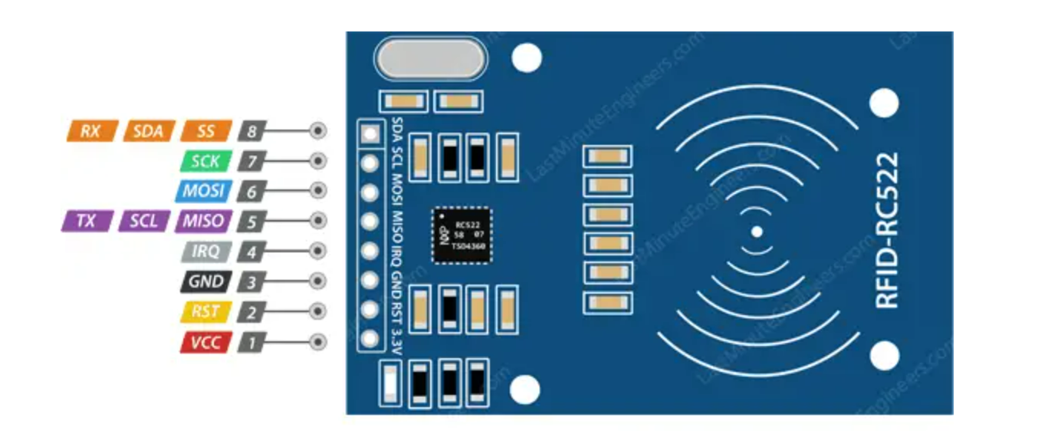

**Connections:**

1. SDA connects to Pin 24.
2. SCK connects to Pin 23.
3. MOSI connects to Pin 19.
4. MISO connects to Pin 21.
5. GND connects to Pin 6.
6. RST connects to Pin 22.
7. 3.3V connects to Pin 1.

**Software configurations:**

**Setting up Raspberry Pi for Serial Communication**

**sudo raspi-config**

In the “Interfacing Options”, select the “Serial” option.

Select **“Yes”** option.

Finish the process and Reboot the Raspberry Pi.

**Following are the terminal command that needs to be executed.**

sudo apt update

python3 -m pip install spidev

pip install mfrc522

**Write the following code in Python 3 IDLE and save it as ‘rfid.py’**

import RPi.GPIO as GPIO

from mfrc522 import SimpleMFRC522

from time import sleep

reader = SimpleMFRC522()

print("Welcome to RFID Practical")

while True:

print("")

print("Choose your Option")

print("1. Write your Tag")

print("2. Read your Tag")

print("3. Delete the content")

print("Press any key to Exit")

print("")

a=input("Enter your option:")

if a=="1":

text=input("New data: ")

print("Now Place your Tag to write")

reader.write(text)

print("Written")

sleep(1)

elif a=="2":

print("Now Place your Tag to read")

id, text=reader.read()

print(id)

print(text)

sleep(1)

elif a=="3":

text=""

print("Now Place your Tag to Reset")

reader.write(text)

print("Data Deleted")

sleep(1)

else:

break

GPIO.cleanup()

[Note: now place the RFID cards one by one over RFID module to check the output]

**Output:**

